1. **Topologi**

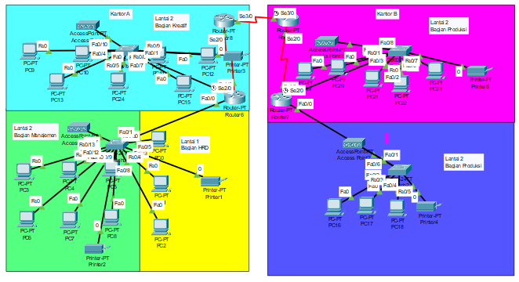

1. **Alokasi IP address**

|  |  |  |  |  |
| --- | --- | --- | --- | --- |
| **Unit** | **Network** | **Range Host** | **Broadcast** | **Subnet Mask** |
| **HRD** | **192.168.10.0** | **192.168.10.1 – 192.168.10.14** | **192.168.10.15** | **255.255.255.240** |
| **Manajemen** | **192.168.10.16** | **192.168.10.17 – 192.168.10.30** | **192.168.10.31** | **255.255.255.240** |
| **Wifi Lantai 1 Gedung A** | **192.168.10.32** | **192.168.10.33 – 192.168.10.46** | **192.168.10.47** | **255.255.255.240** |
| **Kreatif** | **192.168.10.48** | **192.168.10.49 – 192.168.10.62** | **192.168.10.63** | **255.255.255.240** |
| **Wifi Lantai 2 Gedung A** | **192.168.10.64** | **192.168.10.65 – 192.168.10.78** | **192.168.10.79** | **255.255.255.240** |
| **Produksi Lantai 1** | **192.168.20.0** | **192.168.20.1 – 192.168.20.14** | **192.168.20.15** | **255.255.255.240** |
| **Wifi Lantai 1 Gedung B** | **192.168.20.16** | **192.168.20.17 – 192.168.20.30** | **192.168.20.31** | **255.255.255.240** |
| **Produksi Lantai 2** | **192.168.20.32** | **192.168.20.33 – 192.168.20.46** | **192.168.20.47** | **255.255.255.240** |
| **Router OSPF A ke Router BGP A** | **10.10.10.0** | **10.10.10.1 – 10.10.10.2** | **10.10.10.3** | **255.255.255.252** |
| **Router OSP B ke Router BGP B** | **30.30.30.0** | **30.30.30.1 – 30.30.30.2** | **30.30.30.3** | **255.255.255.252** |
| **Router BGP A Ke B** | **20.20.20.0** | **20.20.20.1 – 20.20.20.2** | **20.20.20.3** | **255.255.255.252** |